Tutorial 5 - SPM (wk 10 done)

Question 1
Team 3

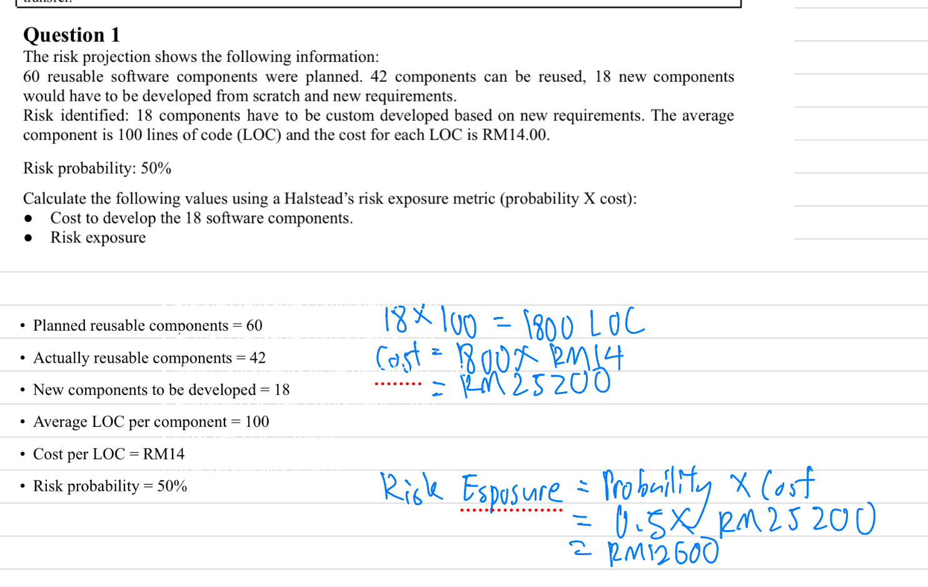

Team 1
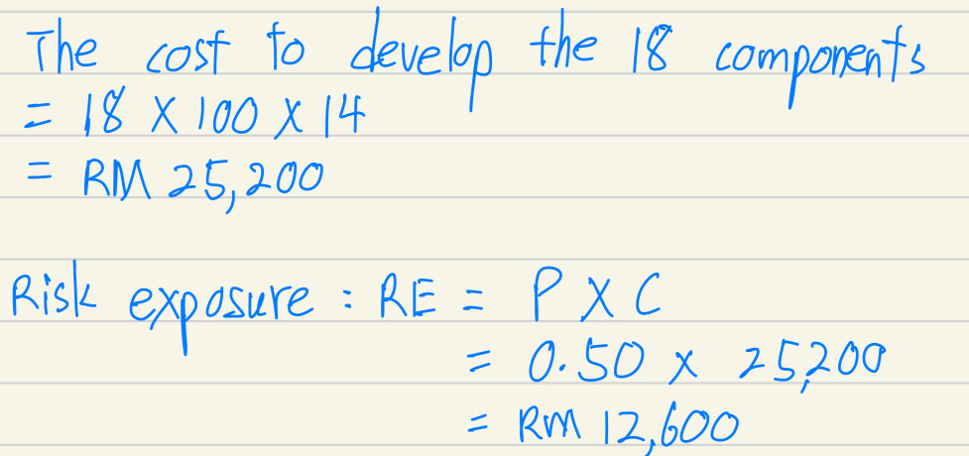

Question 2
Team 4

Strategy type | Reactive risk strategy
When to take action  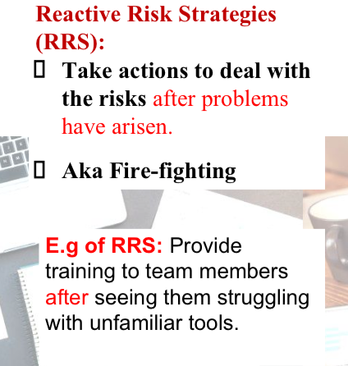 | Take actions to deal with the risk after problems have arisen  For when the risk is urgent to be overcome.
Examples | A project team manager introduces a new IDE to his software developers. Due to not familiar to the IDE, they have trouble to develop using the newly introduced IDE. The project manager sees them and instantly do research, and hire a trainer to train the team to use it.
when comparison question come out:
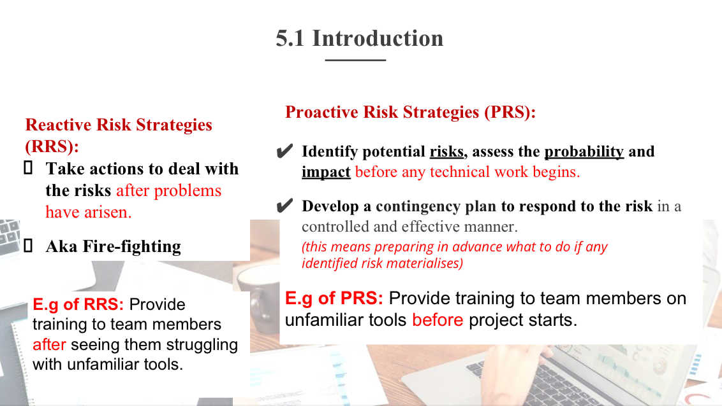

Question 3
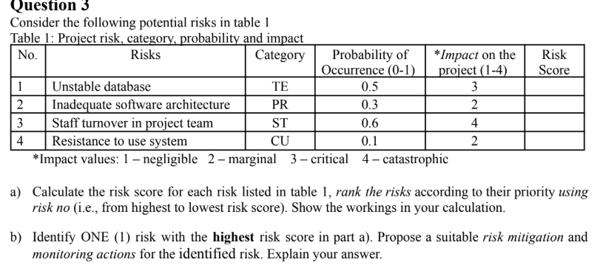
Team1
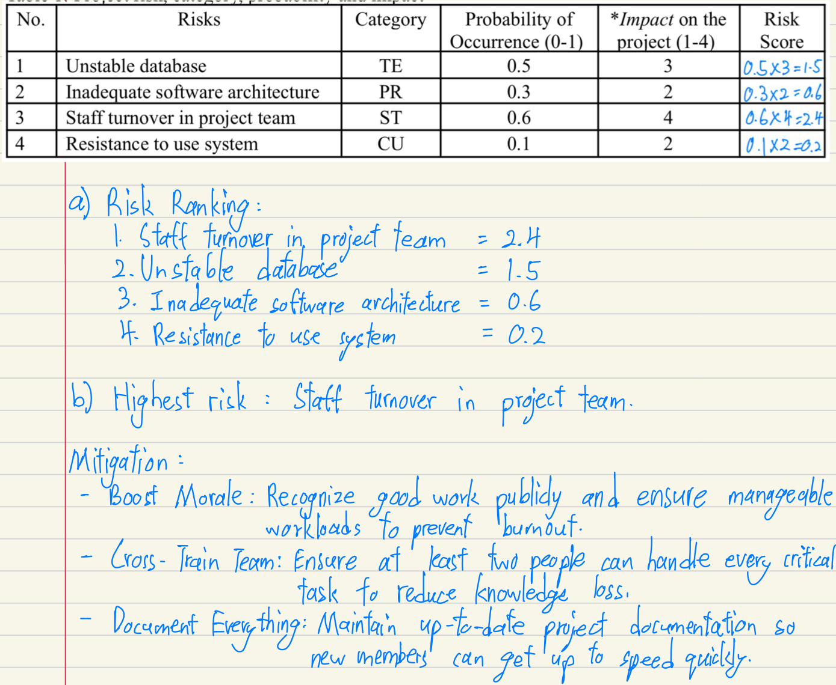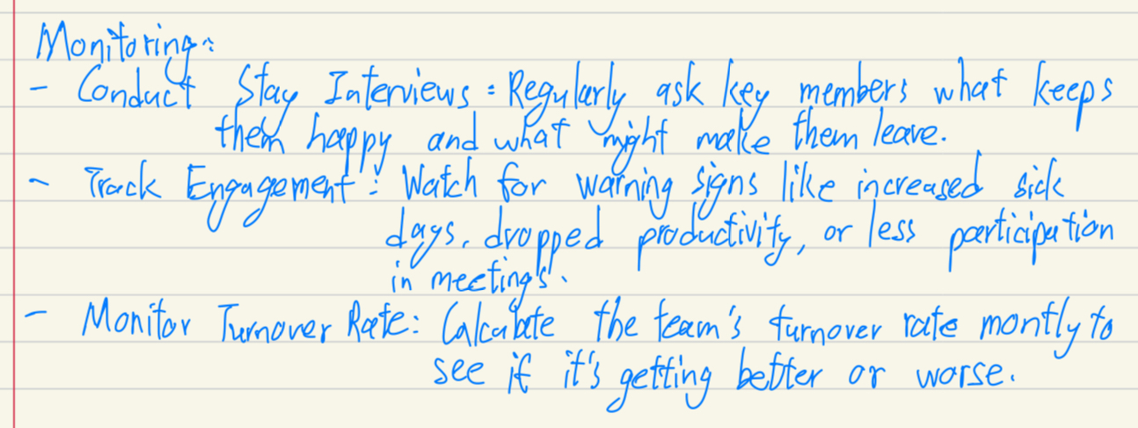

Team 3
